**DAY 3**

### *Server in Nodejs*

* **Server** – A server is a Person who communicates with clients
* Analogy → server = waiter
* Analogy → chef = database
* A server is a **computer program** that's responsible for preparing and delivering data to other computers
* web pages, images, videos, or any additional information

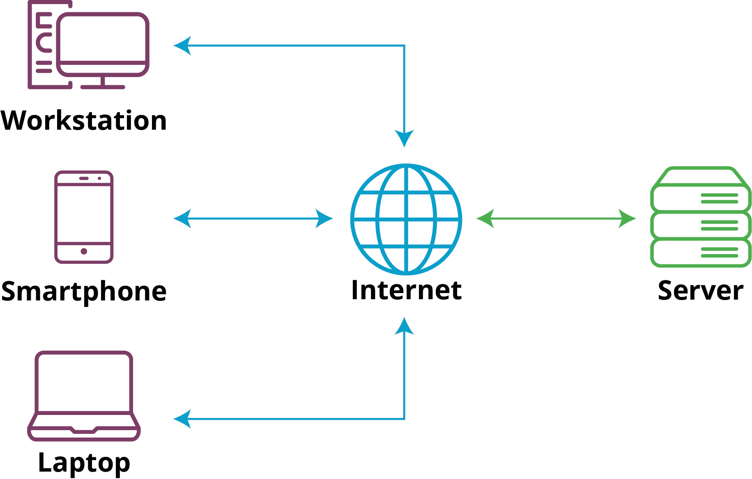

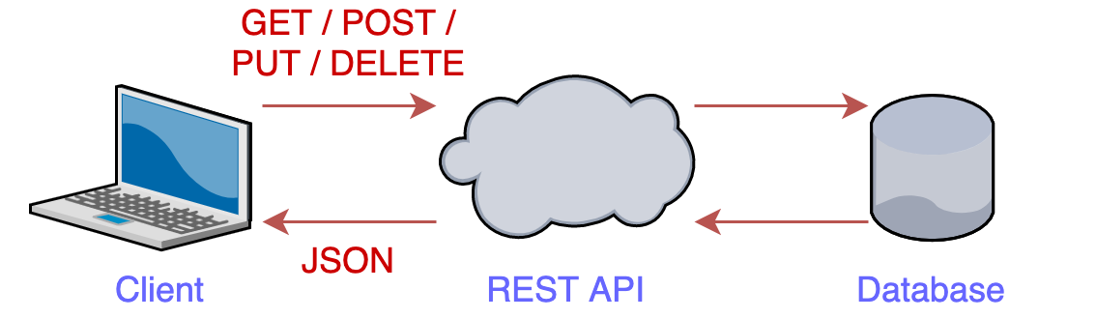

**SERVER**

### **JSON: JavaScript Object Notation**

* Imagine you're sending a message to your friend, and you want to include information like your **name, age, and a list of your favorite hobbies**.
* You can't just send the message as is,
* you need to organize the information in a way that both you and your friend understand.
* JSON is a bit like this organized format for exchanging data between computers.
* JSON is a lightweight
* Structured and organized Data because
* in most contexts, JSON is represented as a string

| {  "name": "Alice",  "age": 25,  "hobbies": ["reading", "painting", "hiking"] } |
| --- |

* **Inter Conversion JSON to an Object in Node.js:**

| const jsonString = '{"name": "John", "age": 30, "city": "New York"}'; const jsonObject = JSON.parse(jsonString); // Convert JSON string to object console.log(jsonObject.name); // Output: John  —---------------------------------------------------------------  const objectToConvert = { name: "Alice", age: 25 }; const jsonStringified = JSON.stringify(objectToConvert); // Convert object to JSON string console.log(jsonStringified); // Output: {"name": "Alice", "age":25} |
| --- |

### **ADVANCED ARCHITECTURE OF WEB FLOW**

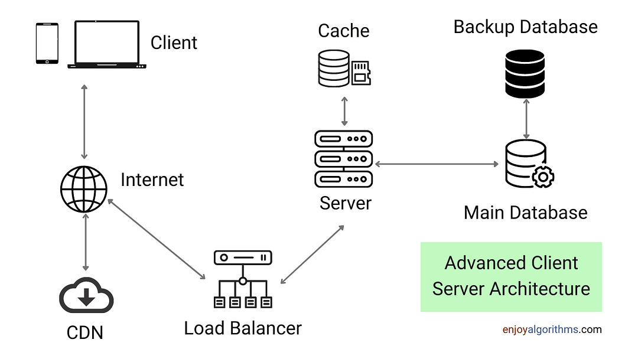

### *What are API and Endpoints?*

* Imagine a menu card in a restaurant
* Lots of options are there, each option will give you a different order
* Now, collection of that list = Menu card = API’s
* And an option in that list = Endpoint
* And the waiter only understood whatever things are written on the menu card

### *Create a server*

* Creating a server in NodeJs via **express** package
* Express.js is a popular framework for building **web applications** and **APIs** using Node.js.
* When you create an Express.js application, you're setting up the **foundation for handling incoming requests** and defining how your application **responds** to them.
* Now we are going to create a server == waiter
* Now the waiter has his own home?

In simple terms, "**localhost**" refers to your **own computer**. After creating a server in NodeJS, you can access your environment in ‘localhost’

* Port Number?
* Let’s suppose in a building – 100 rooms are there, for someone to reach he must know the room number right?

### *Methods to share data*

* Now, in the world of web development, we need to deal with data
* How data is sent and received between a client (like a web browser) and a server (built with Node.js)
* So there are lots of methods out there to **send or receive data** according to their needs.
* GET
* POST
* PATCH
* DELETE
* **GET**
* Imagine you want to read a book on a library shelf.
* You don't change anything
* you just want to get the information.

Similarly, the GET method is used to request data from the server.

For example, when you enter a website URL in your browser,

**your browser sends a GET request to the server to fetch the web page.**

* Code that we have written on the videos

| const express = require('express') const app = express();   app.get('/', function (req, res) {  res.send('Welcome to my hotel... How i can help you ?, we have list of menus') })  app.get('/chicken', (req, res)=>{  res.send('sure sir, i would love to serve chicken') })  app.get('/idli', (req, res)=>{  var customized_idli = {  name: 'rava idli',  size: '10 cm diameter,  is_sambhar: true,  is_chutney: false  }  res.send(customized_idli) })  app.listen(3000, ()=>{  console.log('listening on port 3000'); }) |
| --- |